Project 2

DIG2783

Dexavier Tajaun Chang

10/7/2019

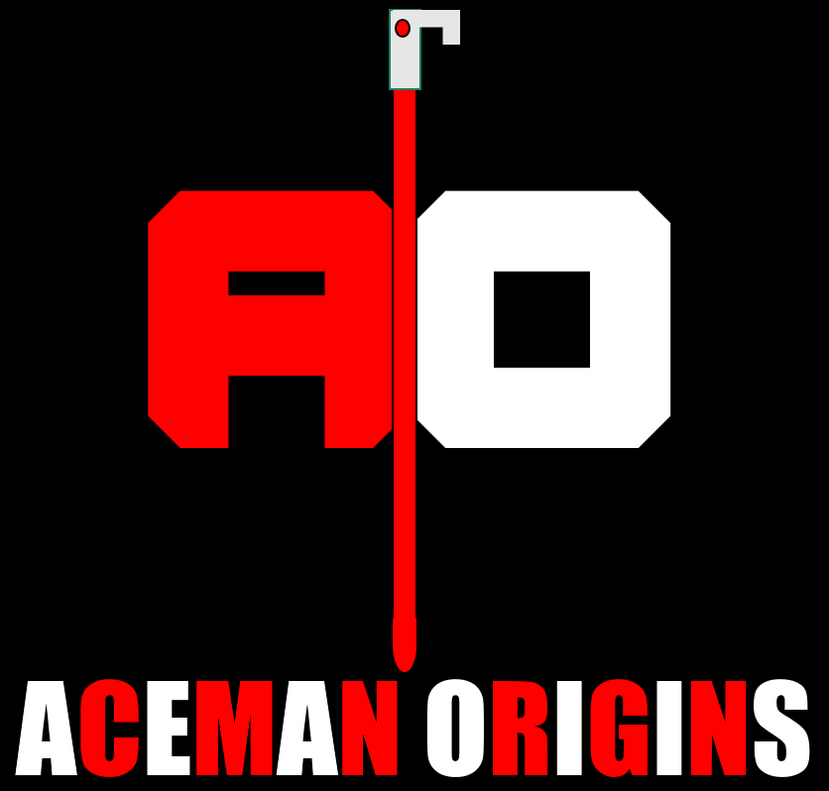

Updated Narrative

Johnathan Brandis is a sixteen-year-old genius. Brandis is known for his crazy gadgets and athletic reflexes. On January of 1975, his orphanage was attacked, and several of his friends were kidnapped as punishment for the owner’s massive debt. The five culprits worked for a drug dealer known as Evan Archer. Archer was known for supplying cocaine, meth, and crack to local areas. Archer didn’t like late fees and was known for doing anything possible to get his money back. The orphanage’s owner’s debt had resulted in something bad. Johnathan was one of the only orphans that avoided being kidnapped or harmed by Archer’s crew. With his Acesword and other strange gadgets, he now becomes the ultimate unlikely hero Aceman. As Aceman, he now faces all new challenges. It is up to him to rescue the hostages and take out Evan Archer’s Crew. Will he succeed, or will he die trying?

Character Aesthetic Summary

For Aceman, his aesthetic is based upon a mixture of comic book superheroes. I have borrowed influences from Spiderman, Batman, and even Rayman to develop him. There is nothing too fancy or complicated about him. His outfit is styled like a luchador’s outfit. I wanted his look to reflect on his underdog status. My goal was to make him look as less like a superhero as possible. He is supposed to look basic, as he uses his shabby clothes as his own costume.

For Evan Archer, several villains have influenced his design. The Green Goblin, the Shocker, and Emperor Zurg have certain design aspects I tried to emulate. I wanted to go for an all-out powerful and evil aesthetic for Archer. There is nothing remotely good about Evan Archer. How and why he became a drug dealing psychopath is unknown. What is known, is that in 1974, he had a bad accident and would forever conceal his body under a suit. Archer’s design reflects his pure evilness to the bone.

The overall aesthetic for Aceman is based around the landscape of heroes and villains in general. I have had countless hours and thoughts about how I’m going to try and implement this into the project. I want viewers to feel like Aceman is a hero who can hold his own.

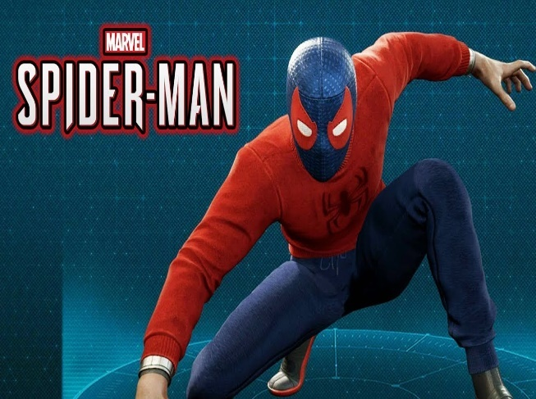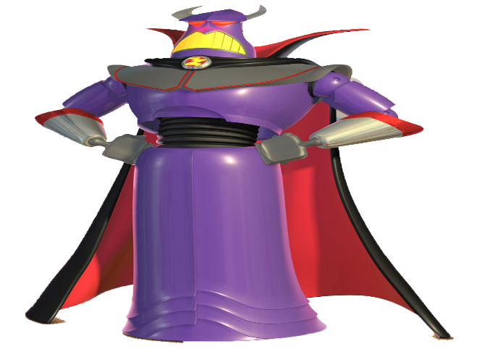

Character Color Palettes

Aceman’s

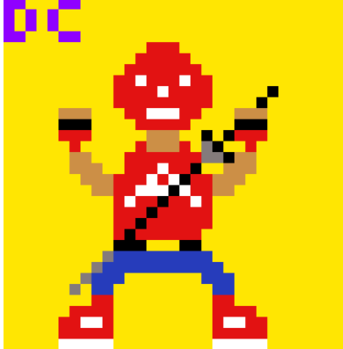

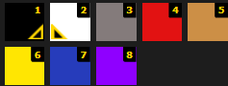

1.#000000

2.#FFFFFF

3.#847B4B

4.#E21212

5.#CC8F46

6.#FFE602

7.#263CBB

8. n/a Not a part of Aceman’s design.

Evan Archer

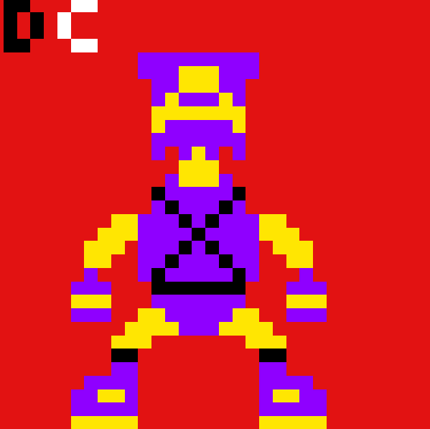



1.#000000

2.#FFFFFF

3. n/a Not a part of Archer’s design.

4.#FFE602

5.#8F00FF

Character Proportion Comparison

